Laboratory work №4 Characteristics of light emitting diodes
A light-emitting diode is a p-n junction rectifier. When p- and n-type semiconductors are brought together to form a p-n junction, electrons with energies in the conduction band diffuse from the n-side to the p-side and holes with energies in the valence band diffuse from the p-side to the n-side. Without an externally applied voltage, a diffusion potential V_{D} is generated in the depletion layer between the n-type and the p-type material. The diffusion potential prevents more electrons and holes from leaving the n- and p-regions, respectively, and entering the opposite regions. When an external forward biased voltage V is applied, the potential barrier is reduced. When V ~ V_{D} the height of the barrier is approximately zero and electrons can flow from the n-side to the p-side. Recombination of electrons and holes now can continue and a current will flow across the junction from the p-type to the n-type material. During the recombination energy is released. It can be released in the form of a photon with energy hf ~ E_{g}, where E_{g} is the width of the bad gap of the semiconductor.
If we measure the minimum voltage V_{min} required to cause photon emission, and we measure the wavelength of the emitted photons and use it to calculate the photon energy hf, we always find that eV_{min} < hf. Some of the photon energy is supplied by thermal energy. In order to predict the wavelength of the photons emitted by a LED, we must take into account the distribution of charge carriers in the semiconductor material. The peak emission is expected at a photon energy somewhat higher than the E_{g}.
The anatomy of a common LED is shown below.
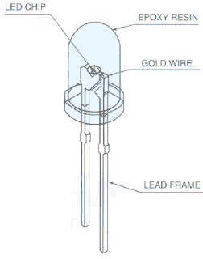
The circuit symbol is 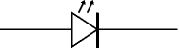 .
Forward bias requires that the voltage at the anode (a) of the LED is positive with respect to the voltage at the cathode (k). The cathode has the shorter lead. 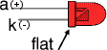
Caution: Never connect an LED directly to a battery or power supply!
It will be destroyed almost instantly because too much current will pass through and burn it out. LEDs must have a resistor in series to limit the current to a safe value. A 1 kΩ resistor is suitable for most LEDs if the supply voltage is 12V or less. The color of the plastic case around a LED chip does not always indicate the color of the emitted light.
The table below lists the physical properties of typical LEDs.
Physical Properties of the LEDs
 | Red Diode | Yellow Diode | Green Diode | Blue Diode
Wavelength (nm) | 665±15 | 590±15 | 560±15 | 460±15
Color | Red | Yellow | Green | Blue
Composition | GaAs.₆P.₄: N | GaAs.₁₅P.₈₅: N | GaP:N | InGaN

We now consider another application of the p-n junction, as a light source. In this
incarnation, it is known as a light-emitting diode (or LED). Now, in Chapter 11, we
described electroluminescence as a mechanism for generating photons in a direct-gap
semiconductor. However, an isolated lump of material will not emit significant quantities of
light, because in thermal equilibrium at room temperature the number of downward electron
transitions is extremely small. To improve the optical output, we must move the material far
from equilibrium, so that the rate of spontaneous emission is considerably increased. This
might be done by taking (for example) a p-type material, which already contains a large hole
density, and pouring electrons into it. This can be done in a forward-biased p-n junction.

Figure 12.4-1 illustrates the process; electrons are injected into the p-type material, where
they combine with the holes already present. At the same time, holes are injected into the ntype
material; however, the junction is normally highly asymmetric, so that light emission
takes place mainly from one side.
THE EMISSION SPECTRUM OF AN LED
Once again, we recall that spontaneous emission generates photons that travel in random
directions, so the emission is isotropic; as we will show later, this greatly reduces the
external efficiency of an LED. The emission is also unpolarized. Furthermore, we note that
the output does not consist only of light at the wavelength λg = hc/Eg, as a two-state model
would imply. Because of the wide distribution of carrier energies within the conduction and
valence band, the output is incoherent, with a spectrum consisting of a broad range of
wavelengths (Figure 12.4-2). The electron distribution normally peaks near an energy ≈ 1/2
kT above the edge of the conduction band, and extends for several kT (say, ≈ 5/2 kT) above
Ec. Similarly, the hole distribution peaks at around 1/2 kT below the valence band edge,
extending for about 5/2 kT below Ev. Consequently, the possible photon energies lie in the
range EEg to Eg + 5kT, and the most likely energy is ≈Eg + kT.

Assemble the curcuit
- Power supply
- Constant resistor
- Amperemeter
- Voltmeter (DMM – Digital multymeter)

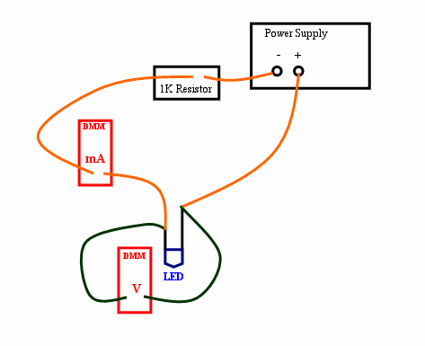
Change the voltage of power supply and measure voltage and current of LED. Also measure luminance of LED using luxmeter. Change the color of LED and repeat the measurements.
Construct IV characteristic.
Calculate power of LED in every experiment. Using luxmeter take lumen/watt characteristics. Using relation between luminous flux and luminance:
$$E=\frac{Φ}{A} (lux)$$
$$Φ=EA (lumen)$$
Construct lumen/watt characteristics. X-axis – power, Y –axis - lumen.
Find the efficiency of LEDs.

